|  |
| --- |
|  |

|  |
| --- |
|  |
| Unit Code: MGMT220  Unit Name: Fundamentals of Business Analytics  Assignment Number: 3  Assignment Name: Data Tables/ Scenarios & Optimization  Student ID: 45197083  Student Name: Justin Lam  Due Date: 25th October  Problem Domain: In this assignment, we are required to produce a report which gives property developer(s) a more realistic assessment of the variability of the allocated Local Government Area (LGA). The assessment is divided into two parts – task one and task two however they are not related to each other.  Task one requires us to take account different types of costs such as stamp duty, construction costs and others to calculate the net profit and the return on investment (ROI) of the project.  Task two, on the other hand requires us to use optimization methods to maximise our profits while finding the optimizing the number of apartments being built.  *Note: These numbers can be negative as we do not guarantee that all projects will yield a positive net profit and return on investment in such project. |
|  |

**Task 1: Data Tables/ Scenarios**

## Net Profit Scenario Summary 1

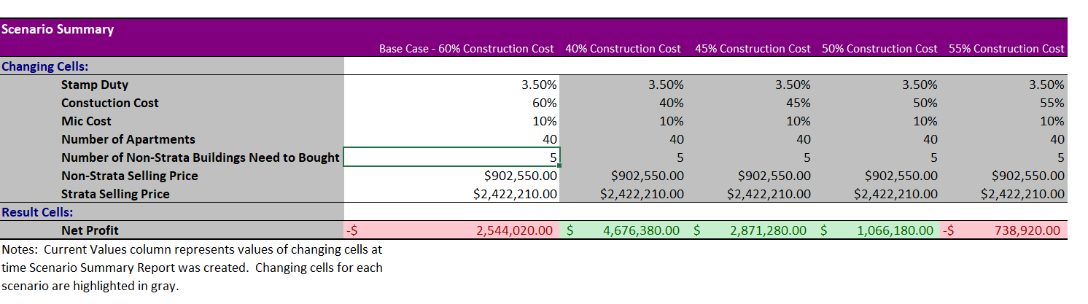

## Interpretation:

The use of scenario manager in Microsoft Excel allows us to simulate the net profit of a property development project by varying the construction costs. Net profit can be calculated by subtracting the revenue of the project and the costs of the project. As seen in figure 1, some of the costs include stamp duty and construction cost. The results generated by the scenario manager and the graph in figure 2 suggest that 60% of construction cost perhaps is not feasible as it records a loss of approximately 2.5 million. While the property developer will be able to make a profit when the construction cost is 40-55%. Nonetheless, it is important to acknowledge the fact that the strata selling price does not vary in such a scenario.

Figure 1

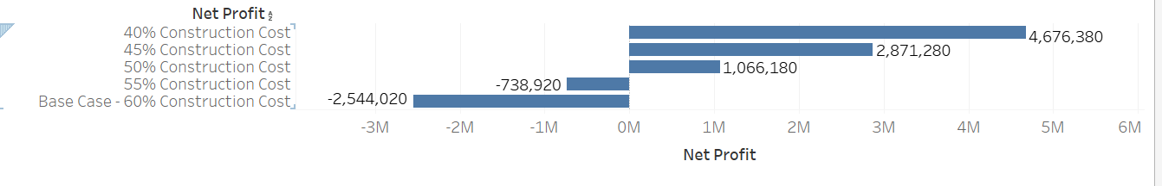

Figure 2

## Net Profit Scenario Summary 2

## Interpretation:

In this scenario, we are simulating scenarios where we vary both construction costs and the strata selling price. From the assignment guidelines, we acknowledged that strata prices could drop as much as 20% as well as a jump by 15% within the time frame. Therefore it will important to take these factors into account when calculating our net profit. By looking the bar chart in figure 4, it is evident to say that, when the construction costs of the project are 40% and strata selling price (either strata prices increases/decreases by 15%/20%), the property developer will able to generate a positive net profit. This scenario also applies when the construction cost is 50% and the selling price increases by 15%. On the other hand, the other scenarios will lead to negative net profit.

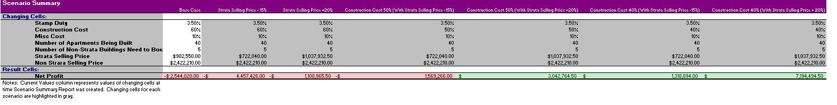

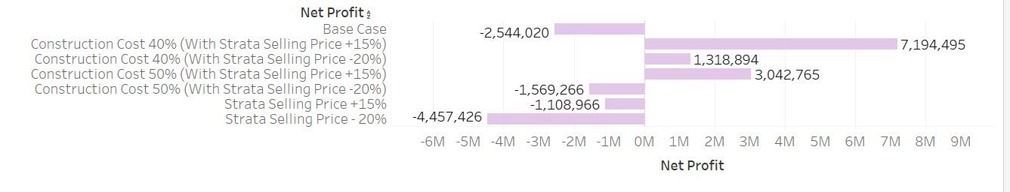

Figure 3

Figure 4

**Return on Investment (ROI) Scenario Summary 1**

**Interpretation:**

Besides net profit, we are also required to calculate the return on investment (ROI) of the project. Return on investment can be used to measure the efficiency of the project – i.e. whether the property developer is benefiting from the project. It can be calculated by dividing the return of the project over the cost of the project from both figures 5 and 6, we are able to comprehend that it is inefficient to develop a property project in both the base cases (-6.58% ROI) and when the construction cost is at 55% (-2.01% ROI). On the other hand, such scenarios were drawn when the prices of both strata and non-strata remain the same. The scenarios below will be used to illustrate such impacts.

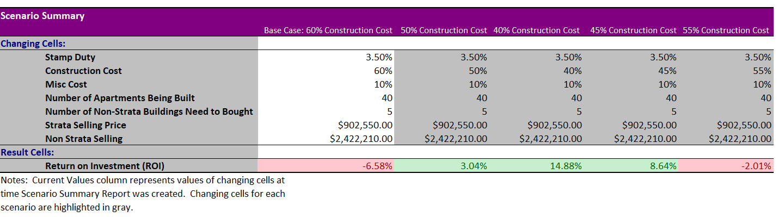

Figure 5

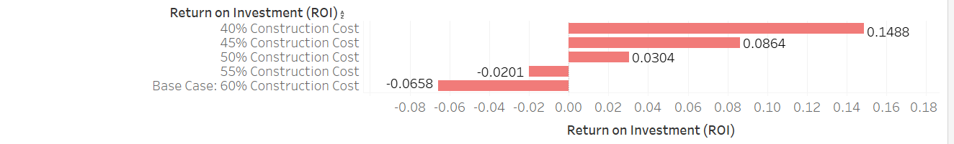

Figure 6

**Return on Investment (ROI) Scenario Summary 2**

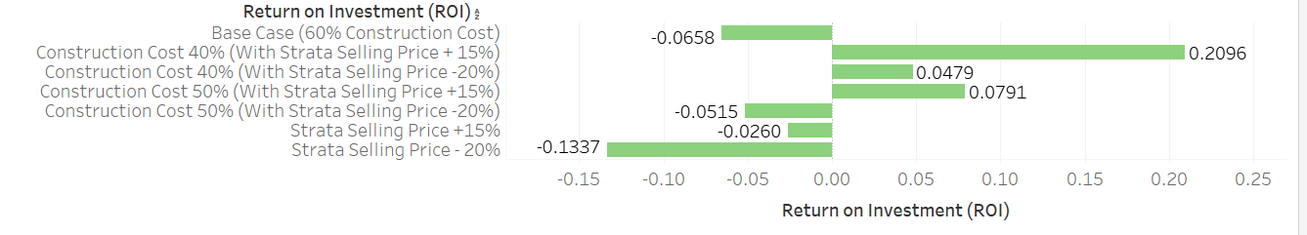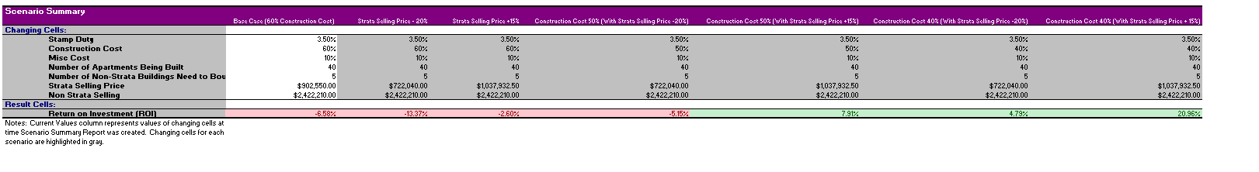

**Interpretation:**

Similarly to net profit scenario summary 2, we need to take the variation of construction cost and strata selling price to get a ‘complete picture’ of the best and worst-case scenarios. As a result, the scenarios between these two will be similar. By looking at both figure 7 and 8, we can notice that only 3 scenarios out 7 can yield a positive ROI. More importantly, they are most likely to occur when the construction cost 40%. Even so, we will not able to control such cost as it will likely vary every month, therefore, property developers always need to pay attention to such changes before investing in a property project.

Figure 8

Figure 7

**Task 2: Optimization**

In this task, we are required to find the optimum number of apartments and floors for the development, assuming stable prices for apartments. Therefore, we do not take account the variation of prices (+15%/-20% strata prices) like we did in task 1 of this assignment.

Additionally, we need to compute a couple values before solving this problem. They are:

* Cost of purchase (which can calculated by multiplying the price of non-strata dwelling in our LGA (Willoughby), 1.45 (as we summed the percentage of costs – 30% for the council required fees.
* Another 15% of the purchase price of the houses, for each floor, after the first floor, in the proposed development.
* Sales revenue (The product between prices and the number of apartments being built)
* We are required to examine the impacts of variation of construction cost (40%, 50% and 60%)

In order to solve such problem, we can use linear integer programming to do so. As mentioned earlier, the objective of such problem is to maximise the net profit by changing levels and apartment number. Such problem must satisfy the following constraints:

* All floors should have a minimum 18 and a maximum 25 apartments.
* The number of apartments should be an integer (i.e. there should be no half/a quarter of a building being built)

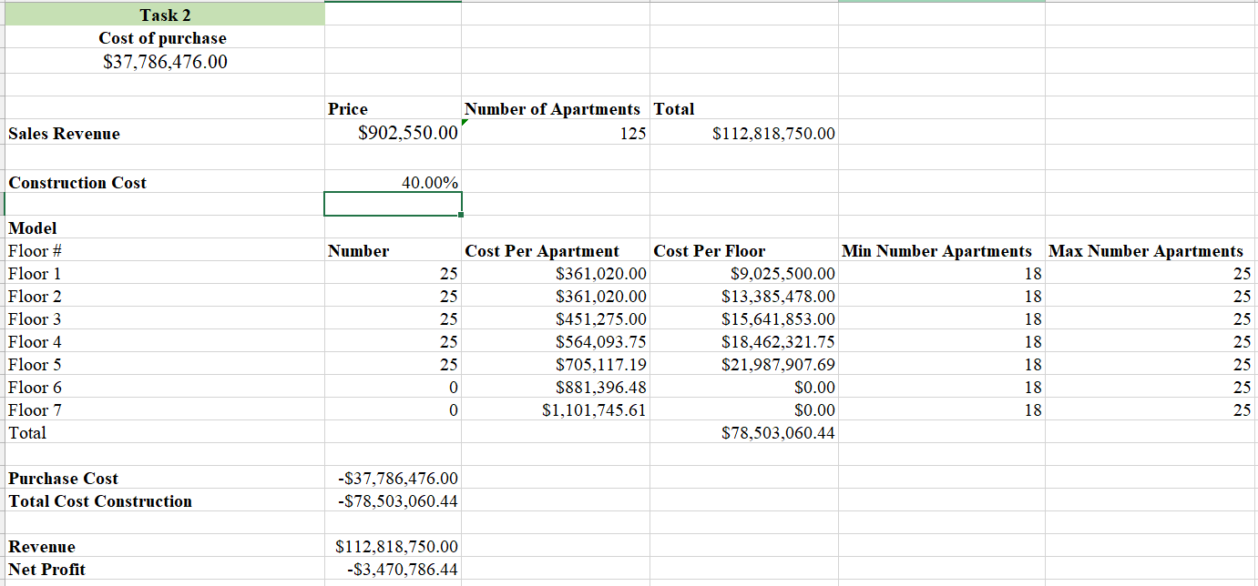A screenshot is attached to demonstrate how the optimisation models going to operate.

**Interpretation:**

An optimization model is built to maximise the net profit of the project while finding the optimum number of apartments. Since the non-strata selling price in our LGA (Willoughby) is approximately averaged at 2.2 million therefore it seems to be unfeasible to purchase non strata dwelling and develop a housing property project one at a time. (Even though the construction cost is at 40%).

However, a property developer is developing multiple property projects in the same time (which is evident in Willoughby), this will maximise its profit in this instance.

Screenshot 1

On the other hand, if we increase our construction costs then our net profit will become even smaller. This proves that our LGA (Willoughby) is not a good places to purchase non-strata dwellings and build strata dwellings afterwards.

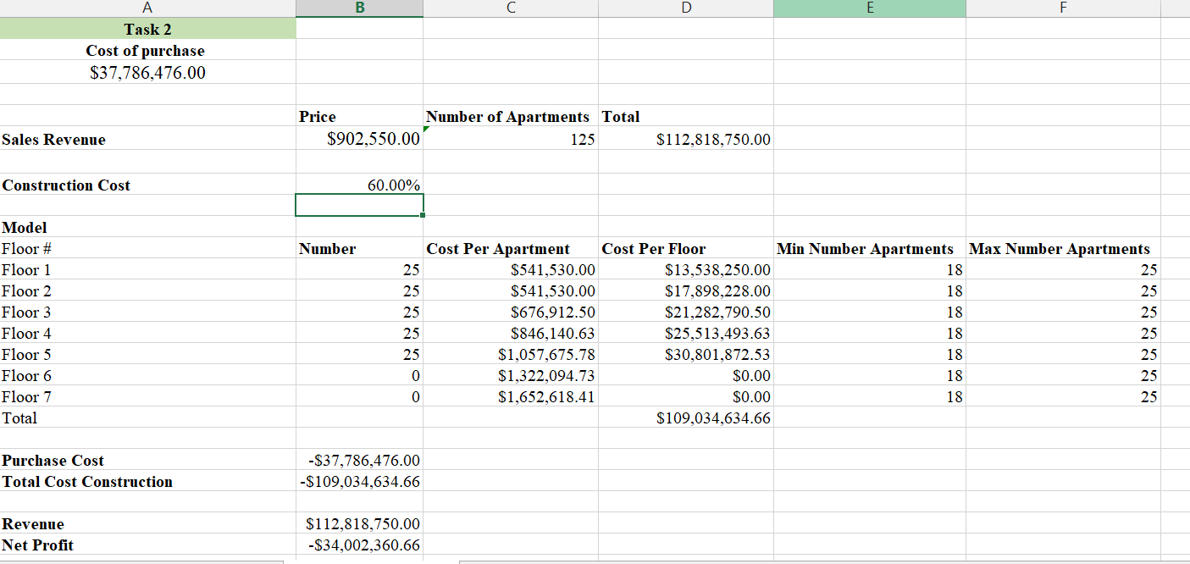

**Conclusion:**

By using optimization, we are able to find the optimum number of number that we are going to build while we maximise our net profit. Unfortunately, our LGA (Willoughby) is not a good LGA to build strata dwellings as we recorded a negative net profit (even though we varied the construction costs from 40% to 60%). It is recommended that property developer(s) should develop multiple projects at once in order to maximise its profit.

Screenshot 2

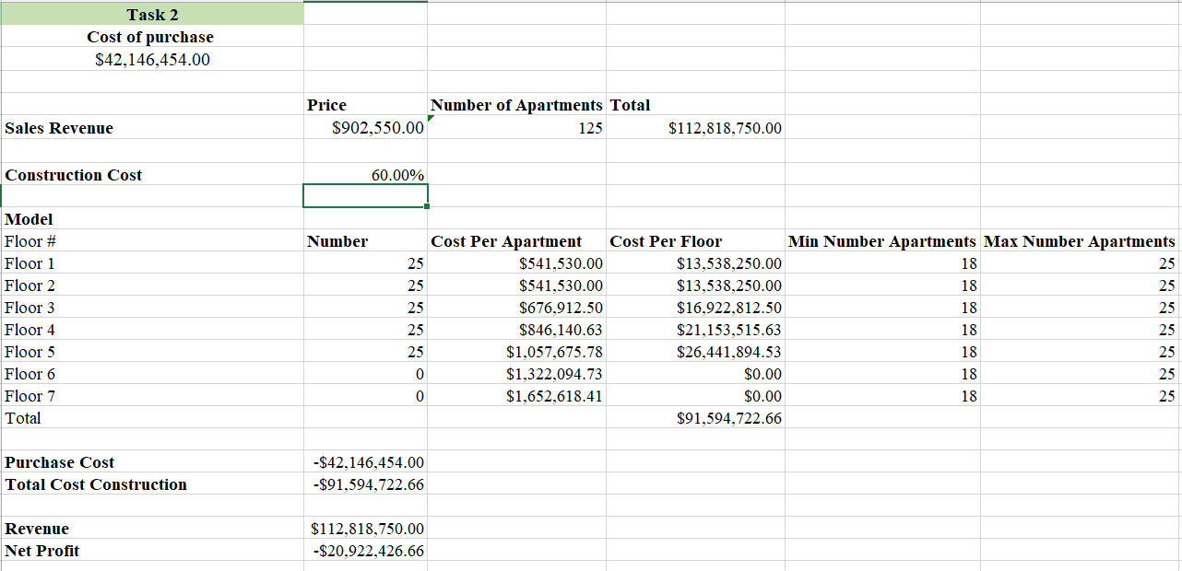

Screenshot 3

Screenshot 3